|  |
| --- |
| **Building Champion Client Portal**details_01 |
| **Analysis Phase. Process Overview**  **Prepared for Building Champions**  **Version 9**  **August 4, 2015** |

Table of Content

[Overall process of Client's registration and work with the Portal 3](#_Toc359498168)

[1.1. Pre-phase (before working with the Portal) 3](#_Toc359498169)

[1.2. Stage 1 Initial Registration 4](#_Toc359498170)

[1.3. Stage 2 Work with the Portal 10](#_Toc359498171)

[1.3.1. Dashboard 11](#_Toc359498172)

[1.3.2. Schedule 14](#_Toc359498173)

[1.3.3. Action Plans 17](#_Toc359498174)

[1.3.4. Documents 19](#_Toc359498175)

[1.3.5. My Information 21](#_Toc359498176)

[1.4. Work with Administrative Console 24](#_Toc359498177)

[1.5. Integration 31](#_Toc359498178)

[1.5.1. SageCRM 31](#_Toc359498179)

[1.5.2. Box.com 31](#_Toc359498180)

[1.6. Assumptions 32](#_Toc359498181)

[Document History 33](#_Toc359498182)

Overall process of Client's registration and work with the Portal

## Pre-phase (before working with the Portal)

1. Client calls to the Building Champions Company via phone. If after an initial phone-call with Coach, Client decides to continue trainings with this Coach, Account Manager creates new record about Client in the SageCRM and selects a program and a Coach. The record about Client contains next data: Client Name, Client Surname, and Client E-mail.

2. Building Champions Client Portal (further the System) retrieves client’s data from SageCRM and creates:

* Login link for the Client. Login link have following structure: http://www.buildingchampions.com/clientportal/<GUID>.

3. The System sends login link to the client’s e-mail. E-mail template:

*Subject:* “Initial Signup”

*Body:* “<NAME>:

Thank you for allowing us to partner with you to improve the way you lead and live.

Before we get started, we need to gather some information from you. Please visit our Building Champions Client Portal <hyperlink to portal log in> to get started.

Once you've completed the Initial Onboarding Checklist, one of our team members will reach out to you to schedule your initial 2-hour coaching session.

If you have any questions, please reach out to our Sales Team at 503.670.1013 or sales@buildingchampions.com.

To Your Success,

The Building Champions Team”

4. Client clicks a link (http://www.buildingchampions.com/clientportal/<GUID>).

5. The System shows Registration form.

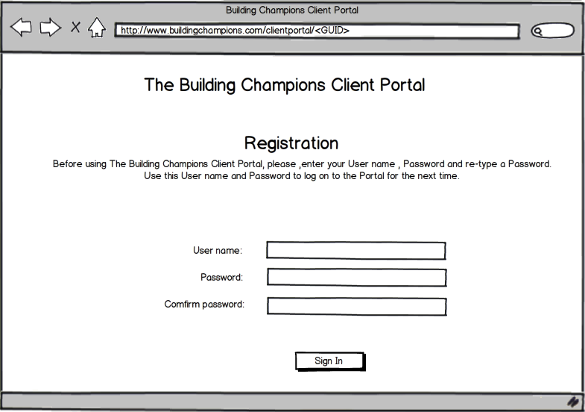

6. Client enters login, password, password confirmation and clicks a button Sign In.

Username is unique and cannot be the same as another user in the System. Password has industry standard security requirements: min 6 characters (e.g. upper- and lowercase Latin letters, digits, special symbols).

The System validates entered username and passwords. If there are any errors the System shows warning.

Jump to step the 7.

Note: If any user access any page in the web application and not-logged in, they should be redirected to the login page.

## Stage 1 Initial Registration

7. The System shows page for the Initial Onboarding with 4 accordion panes: Complete the Client Information Form, Complete Your Questionnaire, Complete Your DISC Communication Assessment, Complete Your Pre-Coaching Survey. All accordion panes are displayed in ‘collapsed’ mode.

The onboarding introduction paragraph contains the next text:

“Thank you for allowing us to partner with you to improve the way you lead and live. Before we can begin, we need to gather some information from you. Please complete the steps below. You don't have to complete them in order, but all of them must be completed before we can schedule your initial 2-hour coaching session. ”

8. Client clicks on accordion button **Complete the Client Information Form**.

9. The System opens section (shows inlay) with fields for entering personal information about Client.

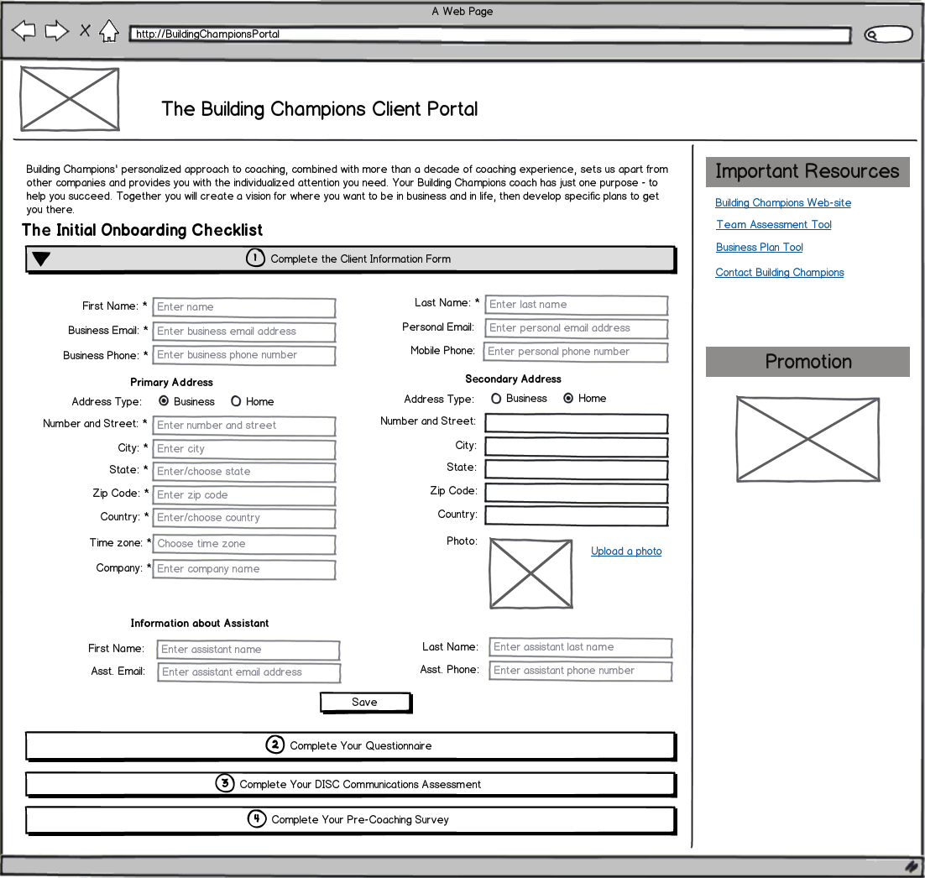

*Note:* There are 4 types of the Client Information Form. The type of the Client Information Form that will be displayed depends on the attribute received from SageCRM.

For Client Information Forms fields description see Appendix.

10. Client enters personal information.

11. Client clicks a link Upload a photo to upload an image. Specify a file (available formats: .jpg, .jpeg, .gif, .png) and clicks **Open**.

12. The system displays image from Client’s file.

13. Client clicks **Save**.

14. The system validates the data entered and saves it to the database. If not all required fields are filled in, the System shows error message:

“The <field\_name> field is required. Please provide necessary information.”

and highlighted fields with issues.

The system shows an accordion button **Complete the Client Information Form** marked as Done in case if all required fields are filled in. Otherwise the button is shown in incomplete view.

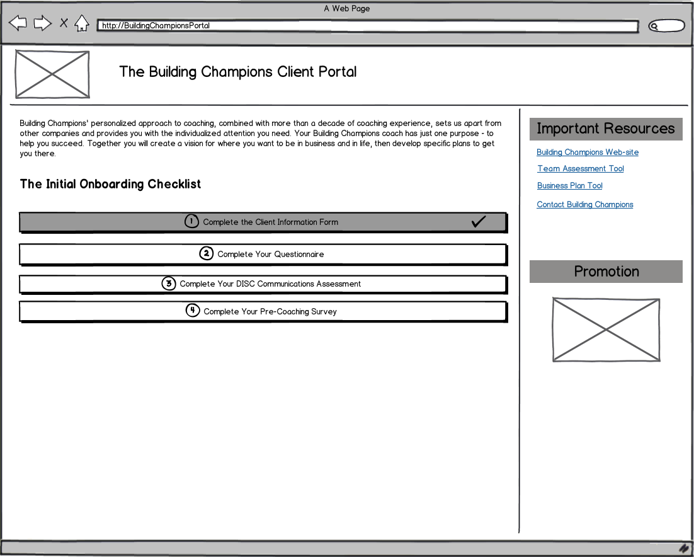

All information entered by the Client is saved into the SageCRM.

15. Client clicks an accordion button **Complete Your Questionnaire**.

16. The System opens section (shows inlay) with Questionnaire.

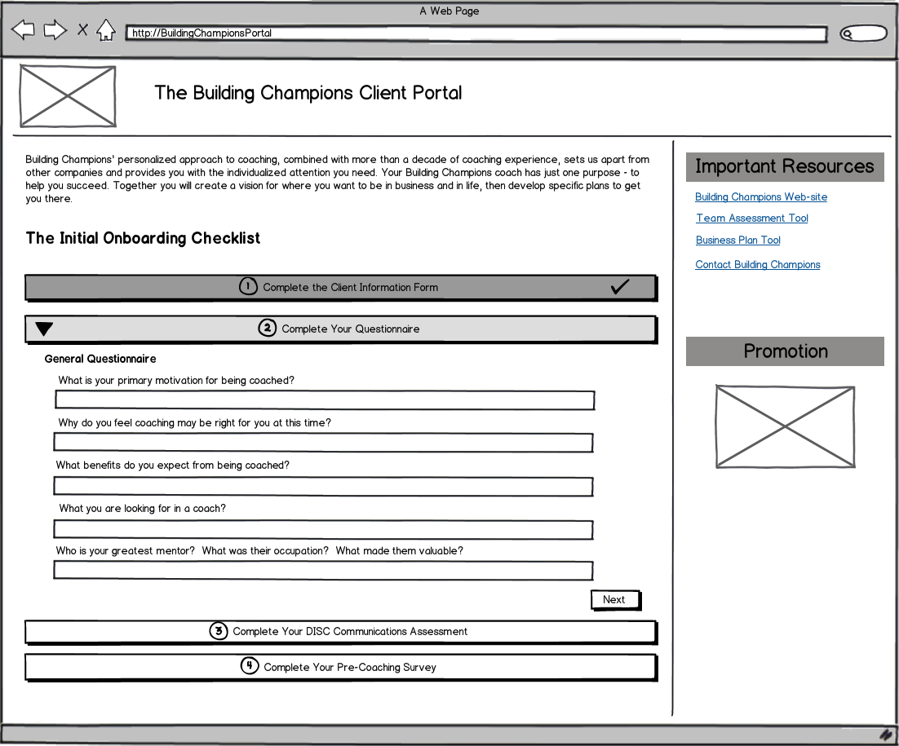

*Note*: There are 4 types of the Questionnaire. The type of the Questionnaire that will be displayed depends on the attribute received from SageCRM.

For Questionnaires fields description see Appendix.

17. Client fills in information. If questionnaire consists of several pages, Client can enter answers (either by typing text either by selecting options) and take a tour over questionnaire questions by clicking **Next** and **Prev** buttons.

Client submits Questionnaire by clicking **Save** button.

18. The system saves the data entered to the database. The system shows an accordion button **Complete Your Questionnaire** marked as Done.

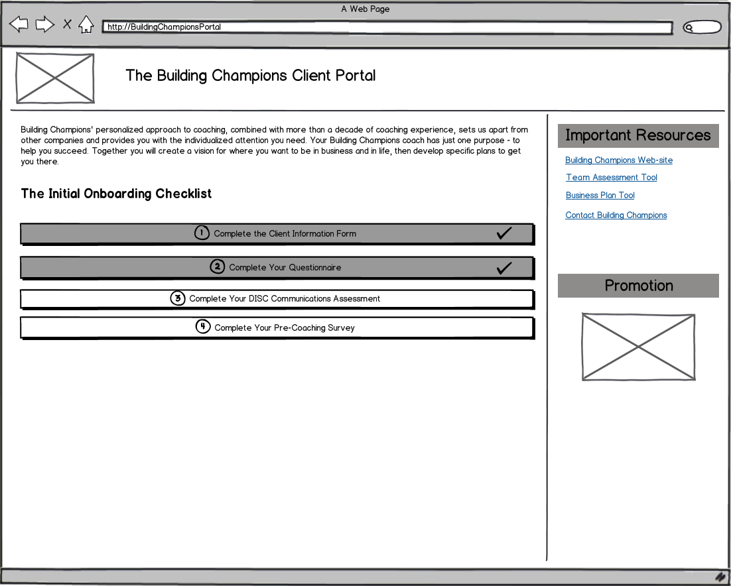

19. Once Questionnaire is completed by the Client, the System sends an email with .pdf file to the Account Representative:

*Subject:* “Client Portal Notification: <Name Surname> Questionnaire”

*Body:* “Client <Name Surname> has just completed their onboarding questionnaire.

See file attached.”

20. Client clicks an accordion button **Complete Your DISC Communication Assessment.**

21. The System opens section with a link to external web-site https://www.ttisurvey.com and client’s password for this DISC link. The client’s password will be retrieved from SageCRM using the query:

select capw\_password from capassword where capw\_personid = 85085 and capw\_category = 6269 and capw\_password != 'N'

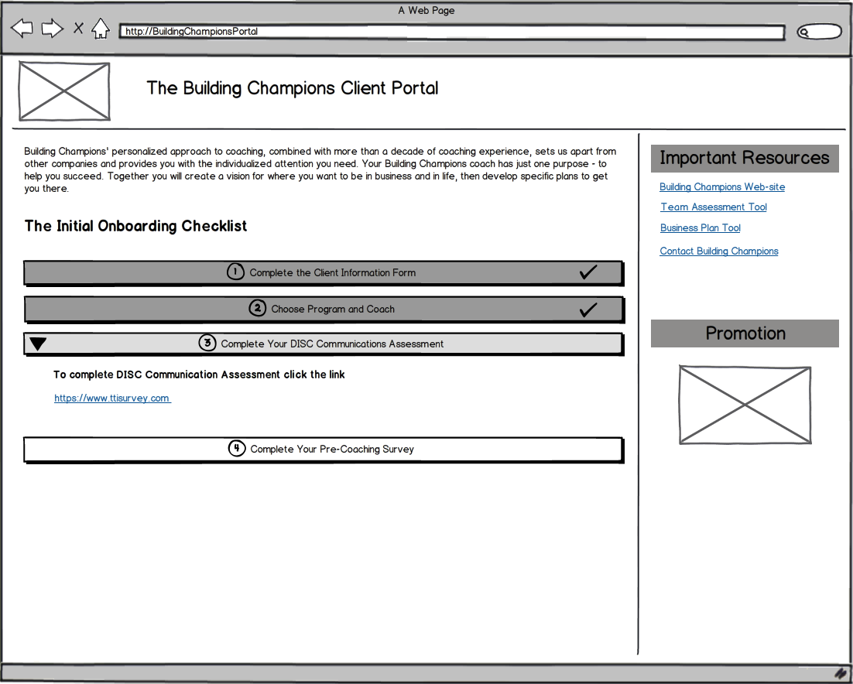

22. After completing the DISC assessment user back to the portal. No information is saved into database.

23. The System shows an accordion button **Complete Your DISC Communication Assessment** marked as Done.

24. Client clicks an accordion button **Complete Your Pre-Coaching Survey.**

25. The System opens section with alink <http://surveys.buildingchampions.com/TakeSurvey.aspx>.

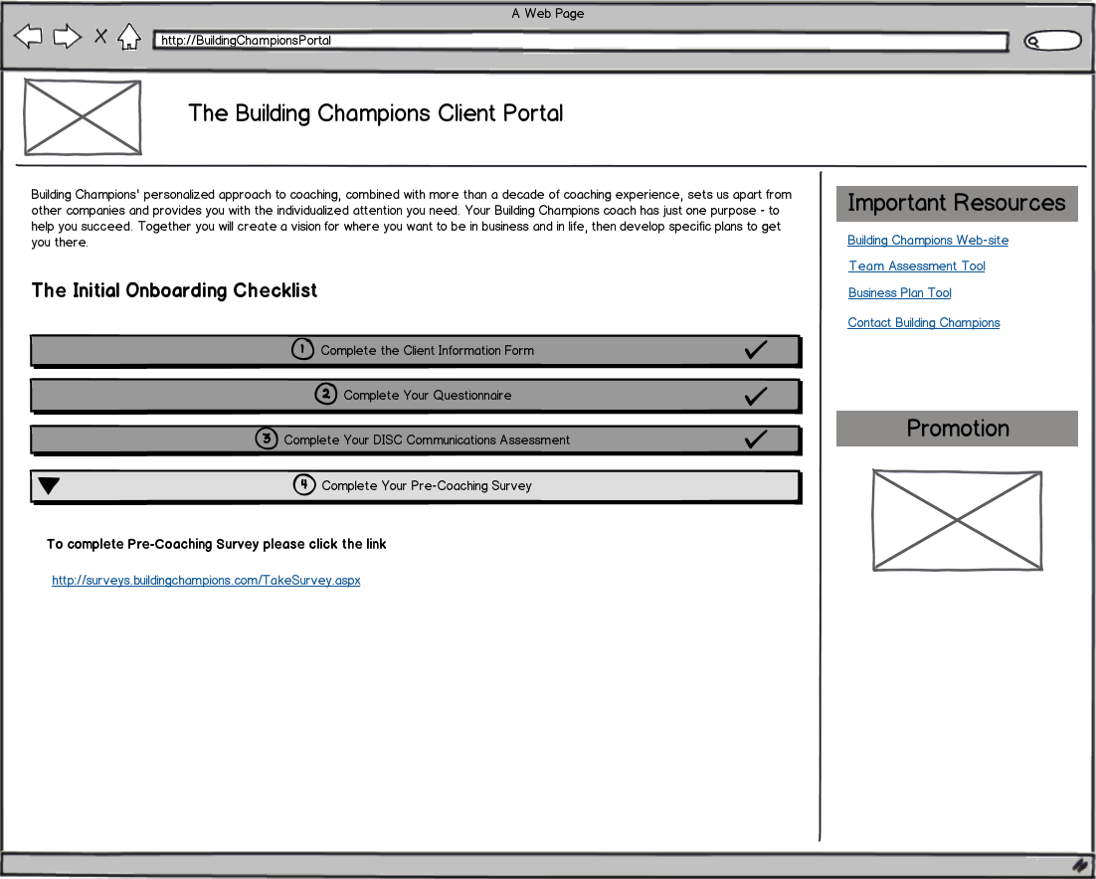

26. When the user completes the survey, survey system redirects the user to the following url: [www.buildingchampions.com/surveyresponse.aspx?responseid=XXXX](http://www.buildingchampions.com/surveyresponse.aspx?responseid=XXXX). This page makes the call to mark the step as completed. The Portal receives information through REST call. No information about survey is saved into database.

27. The System shows an accordion button **Complete Your Pre-Coaching Survey** marked as Done.

After all steps of the Initial Onboarding Checklist have been completed by the Client, the System:

1. Shows to the Client a new page with message text:

“Congratulations on completing your Initial Onboarding Checklist! One of our team members will follow up with you to complete your onboarding and get your first coaching session scheduled.”

1. Sends a confirmation email to the Client. Email template:

*Subject:* “Confirmation”

*Body:* “Congratulations on completing your Initial Onboarding Checklist! One of our team members will follow up with you to complete your onboarding and get your first coaching session scheduled.

If you have any questions, please feel free to contact us at 503.670.1013 or sales@buildingchampions.com

Thank you again for choosing us as your coaching partner. Our entire team looks forward to serving you in the coming months.

Welcome to Building Champions!”

## Stage 2 Work with the Portal

28. Building Champions team member creates in the scheduling application the schedule for this Client and copies information about Sessions (Session name, starting date and time) to the SageCRM.

29. The System receives information about Sessions from the SageCRM and show portal to the Client in the Stage 2.

### Dashboard

30. System shows Dashboard tab with sections: **Notifications**, **Upcoming Sessions**, **Pending Action Plans**, and **Recent Documents**.

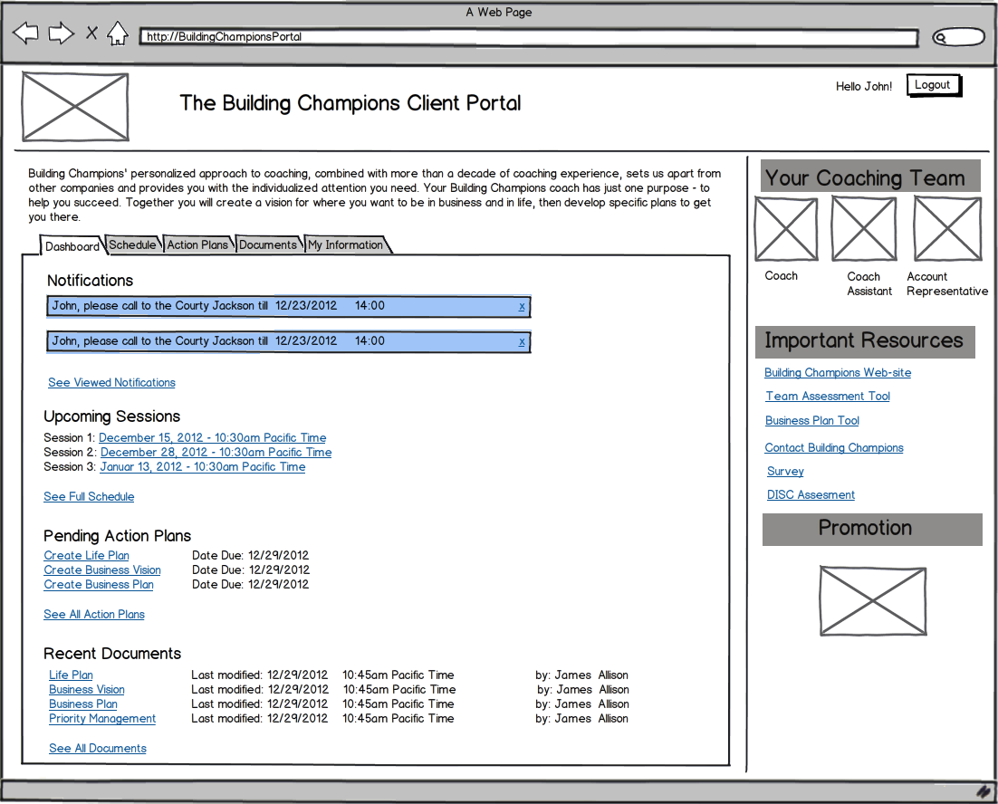

In the section **Notifications** the System displays:

* All new notifications from the Coach (created in the SageCRM by Building Champions Team).
* A link See Viewed Notifications.

After the Client reads a notification, if s/he want marks it as “viewed”, s/he clicks on [**x**]. The System moves notification to the section Viewed Notifications.

In the section **Upcoming Sessions** the System displays:

* The next 3 scheduled Sessions (Session date from current date, missed Sessions doesn’t display). Information about Session: Session number, Session date and Session time. Session dates and times display as links.
* A link See Full Schedule.

In the section **Pending Action Plans** the System displays:

* The next 3 Action Plans (first 3 Date due for incomplete Action Plans, sorted by soonest first ). Information about Action Plan: Action Plan Name, Date due. Action Plan Names display as links.
* A link See All Action Plans.

In the section **Recent Documents** the System displays:

* 4 most recently modified documents (date/time of modifying). Information about Documents: Document Name, Modification Date, Modification Time, Author of modification. Document Names display as links.
* A link See All Documents.

31. Client clicks a link See Viewed Notifications.

32. The System opens inlay with all recent notifications that was marked as “viewed” sorted by the time in descending order. The link See Viewed Notifications replaced by the link Close Viewed Notifications. If the Client clicks a link Close Viewed Notifications the System hides inlay.

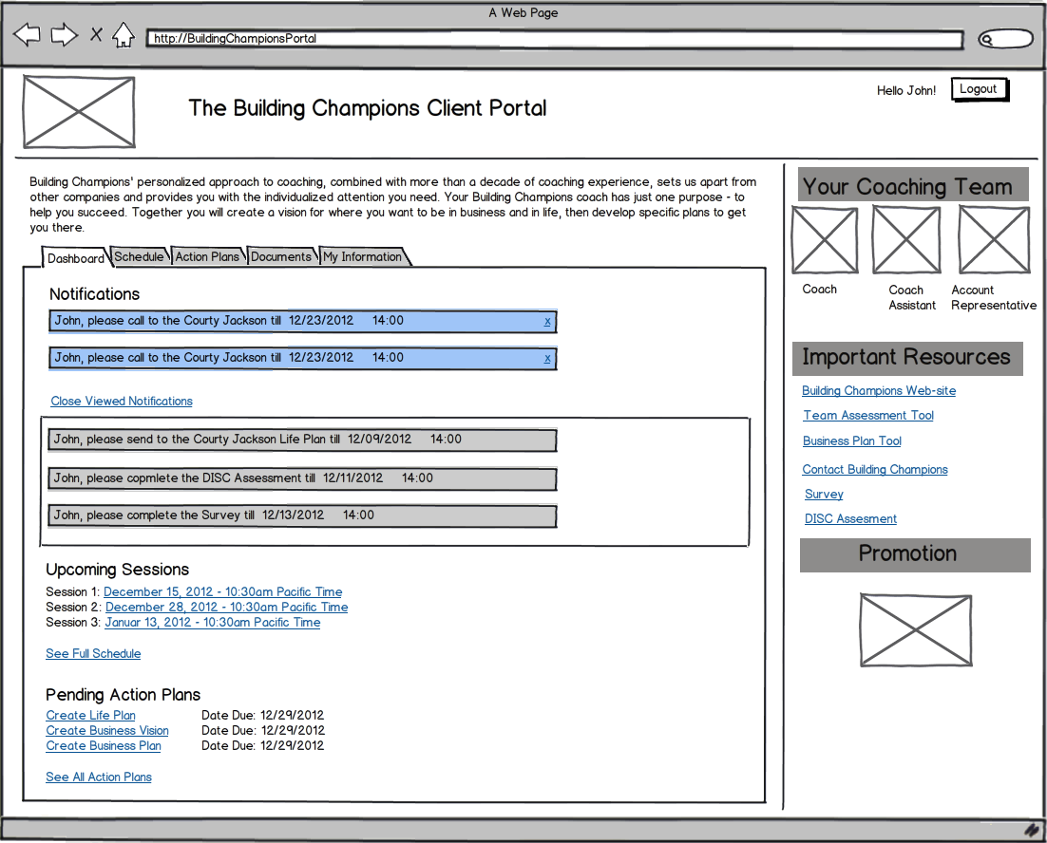

33. Client clicks a link See Full Schedule.

34. The Systems displays tab **Schedule** with the section **Upcoming session** expanded (see details about the tab **Schedule** in the section 1.3.2).

35. Client clicks a link <Session date and time>.

36. The Systems displays tab **Schedule** with expanded inlay for the specified <Session date and time>.

37. Client clicks a link See All Action Plans.

38. The Systems displays tab **Action Plans** with section **Pending Action Plans** expanded (see details about the tab **Action Plans** in the section 1.3.3).

39. Client clicks a link <Action Plan Name>.

40. The Systems displays tab **Action Plans** with expanded inlay for the specified <Action Plan Name>.

41. Client clicks a link See All Documents.

42. The Systems displays tab **Documents** expanded (see details about the tab **Action Plans** in the section 1.3.4).

43. Client clicks a link <Document Name>.

44. The Systems opens overlay with 2 buttons **Open** and **Save as**.

45. Client clicks a tab **My Information.**

46. The Systems displays tab **My Information** (see details about the tab **Action Plans** in the section 1.3.5).

### Schedule

The System receives information about Schedule from SageCRM. The **Schedule** tab has 2 lists of Sessions: **Upcoming Sessions** and **Completed Sessions** and 3 links**:** Add Schedule to the Calendar, Reschedule a Session and Print Full Schedule.

By default the Upcoming session’s list is expanded and the Completed session’s list is collapsed, the client can choose to expand or collapse the view of either. For each session the System shows: **Coaching Year**, **Session Number**, **Session Date**, and **Session Time**. < Series number and session number> lines display as the links in ascending order by session date. Completed session’s list has the same structure. The Systems moves Session from Upcoming session’s list to Completed session’s list after current date/time of the server is more than Session Date and Session Time.

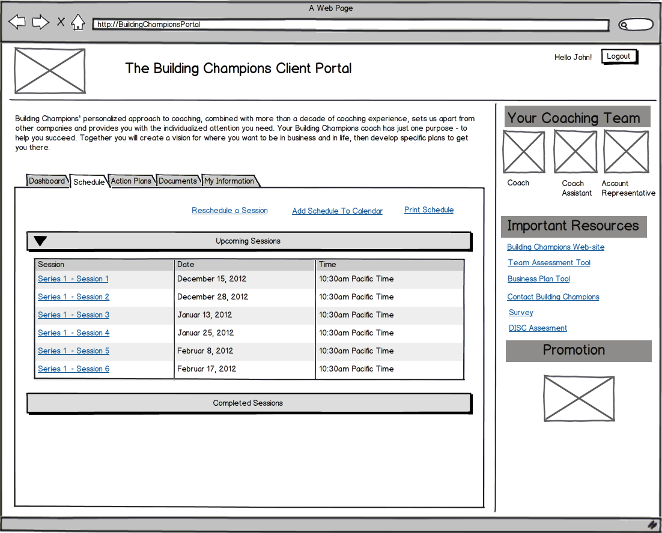

Integration with Calendar should be done with the help of third-party component “add to calendar” widget (<http://addthisevent.com/>)

47. Client clicks a link Add Schedule to the Calendar.

48. The Systems opens overlay with dropdown list. Dropdown list is populated with values: Google Calendar, Yahoo Calendar, Outlook Calendar.

49. Client chooses Outlook Calendar.

50. The System adds all Sessions from the Schedule to the MS Outlook as appointments. Client has to open application MS Outlook and accept all appointments.

51. Client clicks a link Print Full Schedule.

52. The Systems opens Schedule in the PDF-format in the preview-page in the browser (in another tab in the browser). Available operations: **Save as**, **Print**.

53. Client clicks a link <Series number and session number>.

54. The Systems displays inlay for the specified Session. There are 3 simple text input fields without validation: **Hot Topic**, **Greatest Challenge**, and **Greatest Victory**. Client can fill in the data at any time.

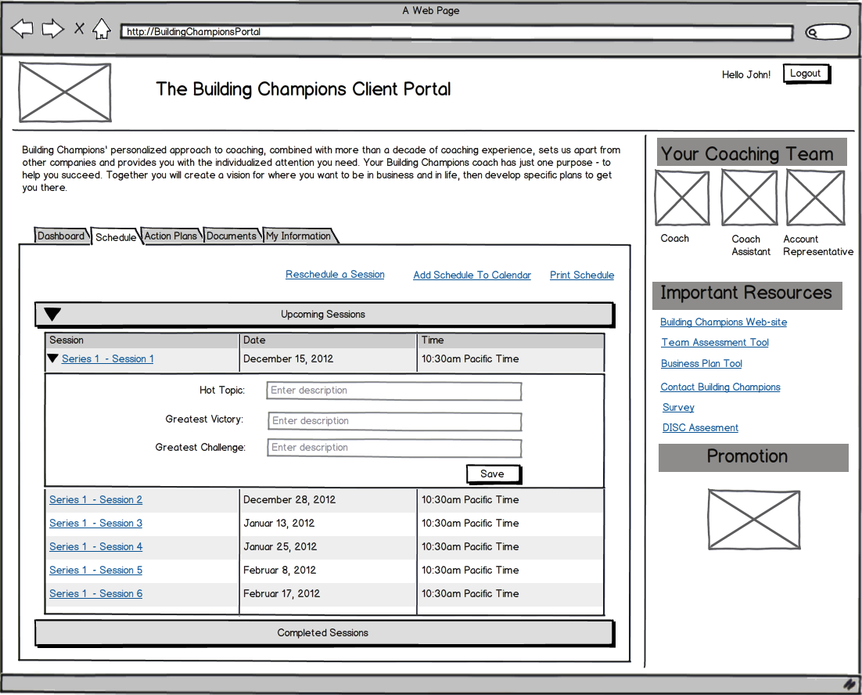

55. Client enters data in the field **Hot Topic, Greatest Victory** and **Greatest Challenge** and clicks **Save**.

56. The System sends entered data to the SageCRM and sends email notification to the Coach.

Email template:

*Subject:* “Client Portal Notification”

*Body:* “Client <Name Surname> has just updated Session’s details on the Portal.”

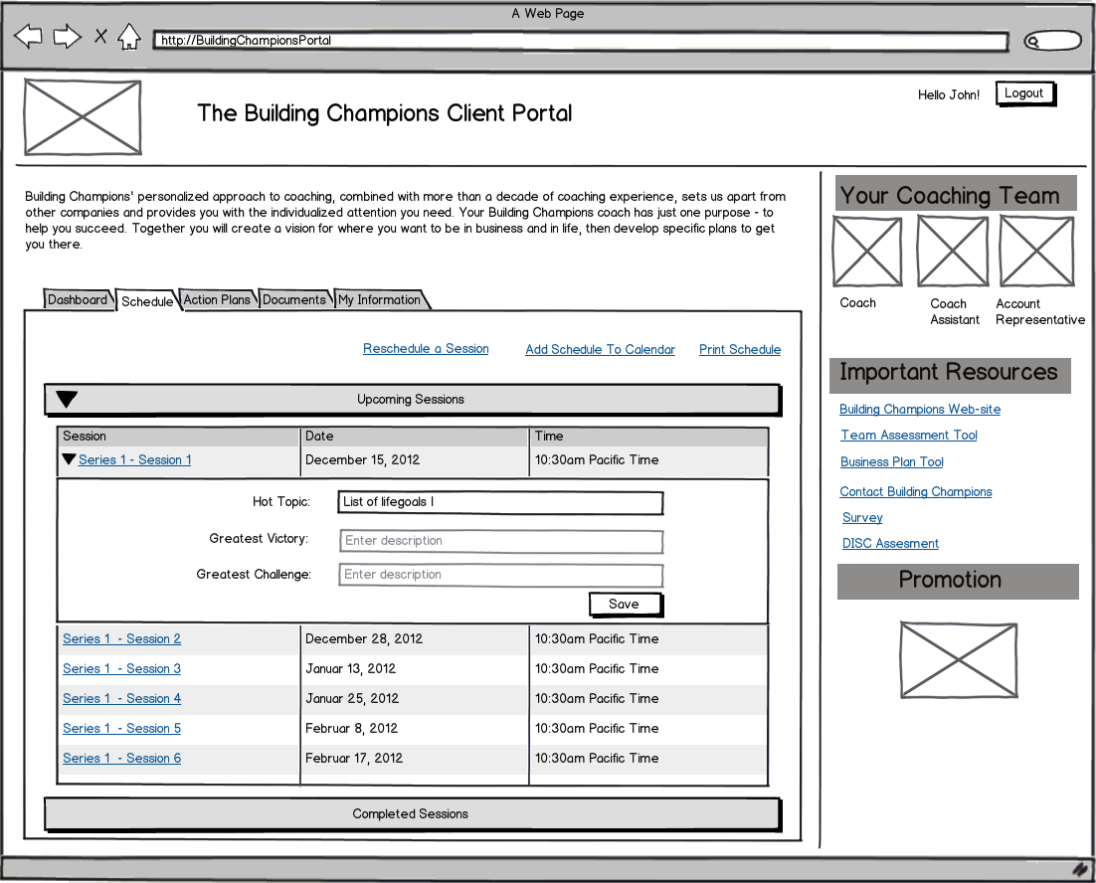

57. Client clicks a link Reschedule a Session.

58. The System opens the web application for scheduling in another browser tab. No any additional authorization is needed.

### Action Plans

59. Client performs rescheduling and returns to the System. The System receives information about Action Plans from SageCRM. The **Action Plans** tab has 2 lists of Action Plans: **Pending** **Action Plans** and **Completed** **Action Plans**.

By default the Pending Action Plans’ list is expanded and the Completed Action Plans’ list is collapsed, the client can choose to expand or collapse the view of either. For pending action plan the System shows: **Action Plan Name**, **Date Due**, **Date Assigned** and a button **Mark as Complete**. For completed action plansthe System shows: **Action Plan Name**, **Date Due**, **Date Assigned** and **Date Completed. Action Plan Names** display as the links in ascending order by due date.

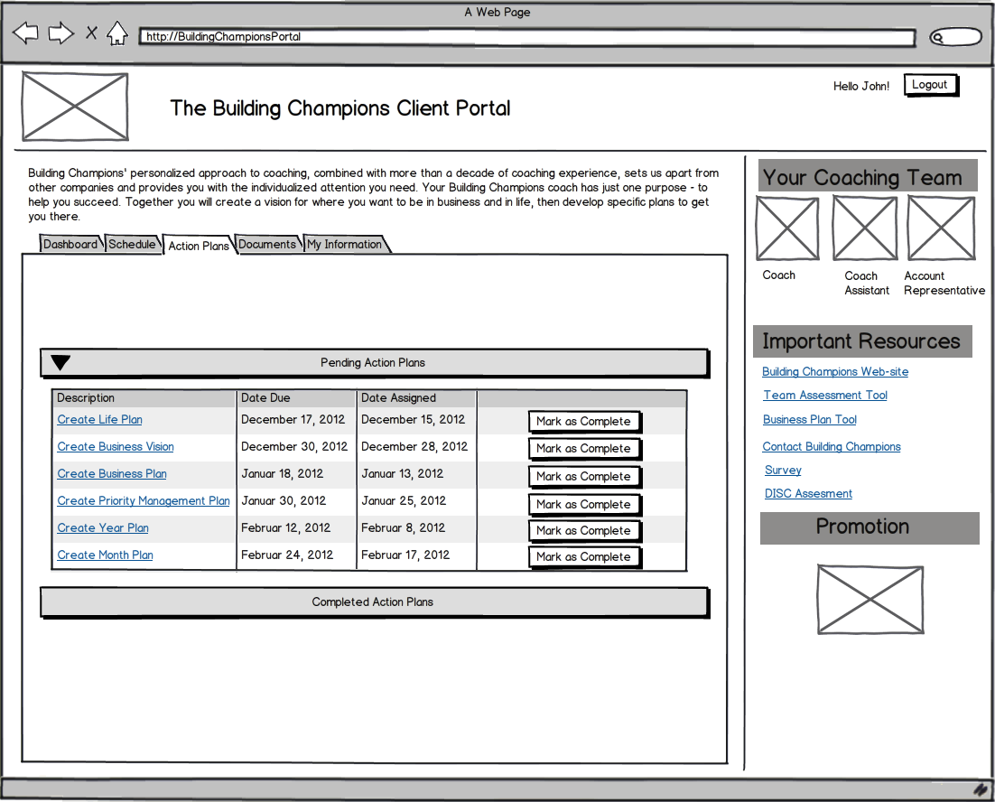

60. Client clicks a button **Mark as Complete**.

61. The Systems moves Action Plan from Pending Action Plans’ list to Completed Action Plans’ list. The System binds current date of the server as **Date Completed** for the action plan.

62. The System sends email notification to the Coach.

Email template:

*Subject:* “Client Portal Notification”

*Body:* “Client <Name Surname> has just marked Action Plan <Action Plan Name> as complete on the Portal.”

63. Client clicks a link <Action Plan Name>

64. The Systems displays inlay with detailed description for the Action Plan.

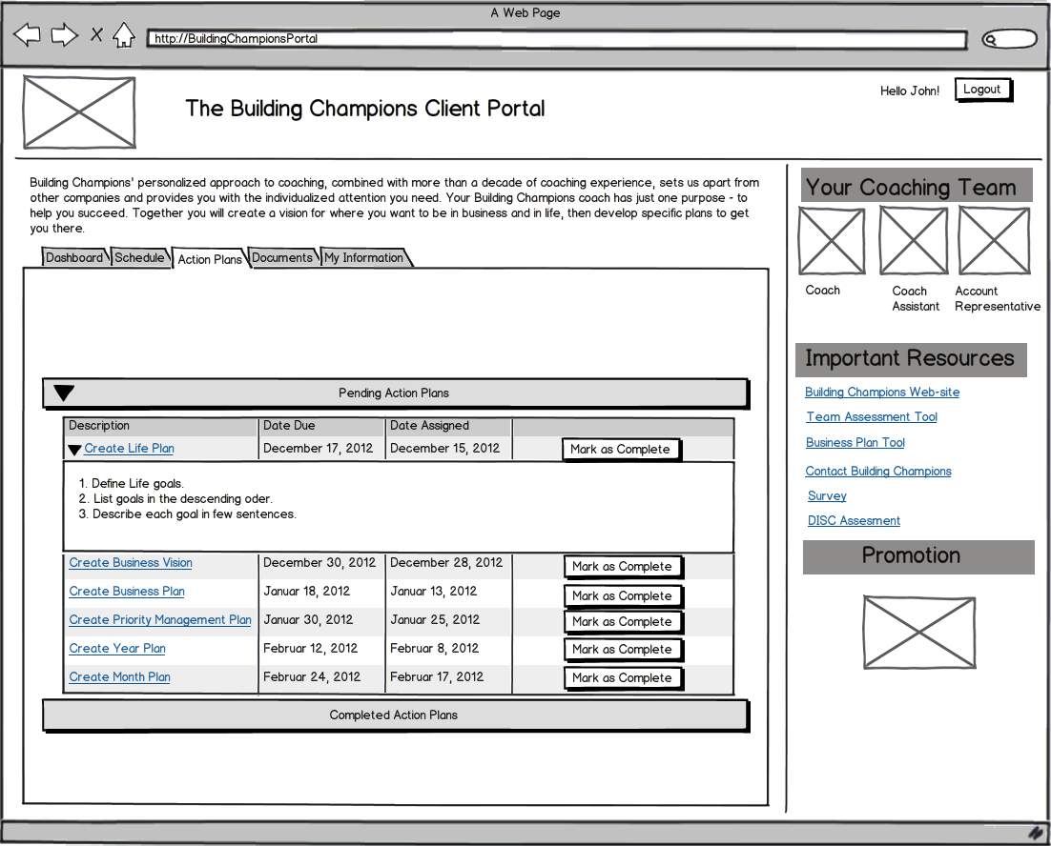

### Documents

The **Documents** tab has 2 lists of Documents: **Core Four Documents** and **Other Documents** and a link Upload File. The list **Core Four Documents** is pre-populated with a set of document that is specific to the coach (the System receive these files from SageCRM).

By default both lists are collapsed, the client can choose to expand or collapse the view. For each file the System shows: **File Name**, date and time of modification(**Last modified**), author of modification (**Modified by**). <File Names> display as the links.

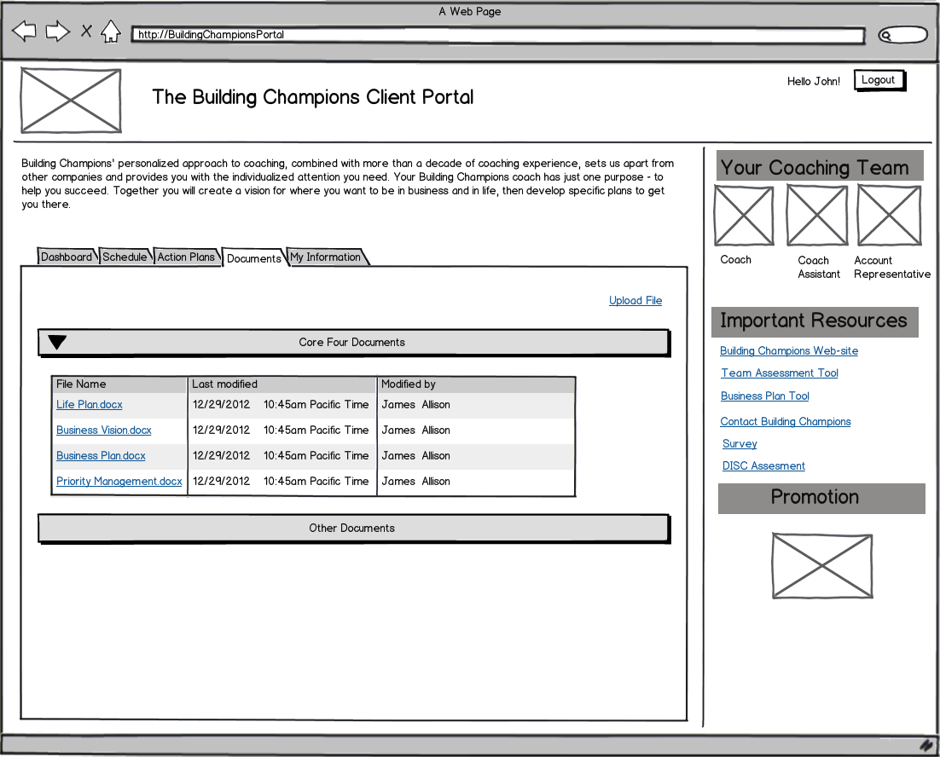

65. Client clicks a link Upload File.

66. The Systems opens standard dialog for choosing files. Client specifies file, the System uploads this file to the Portal and to the SageCRM and sends email notification about file uploading to the Coach.

Client can upload files with the next format: .doc, .docx, .xls, .xlsx, .pdf, .png, .jpeg, .jpg, .tif.

Size limitation: 10Mb.

Email template:

*Subject:* “Client Portal Notification”

*Body:* “Client <Name Surname> has just uploaded file to the Portal.”

67. Client clicks a link <File Names>.

68. The Systems opens overlay with 2 buttons **Open** and **Save as**.

69. Client clicks a button **Open**.

70. The System downloads the document to the users’ temp folder and opens the document up in the users’ default program for that file type in the editable mode. Client can browse, edit, print document using default program’s tools. Client can save any edits and have the document changes saved within the portal without having the “re-upload” it.

71. Client clicks a button **Save as**.

72. The System opens standard Save as dialog to allow the client to download the file and store it locally on the hard drive.

*Note*: Box.com will be used as cloud storage.

### My Information

On **My Information** tab clients can update their contact information, demographic information, and payment information. When this information is updated on the Portal, the System updates it in the SageCRM. The **My Information** tab has 3 lists: **Account Information**, **Contact Information** and **Payment Information**. By default all lists are collapsed, the client can choose to expand or collapse the view.

73. Client clicks on the section **Account Information**.

74. The Systems opens section **Account Information**.

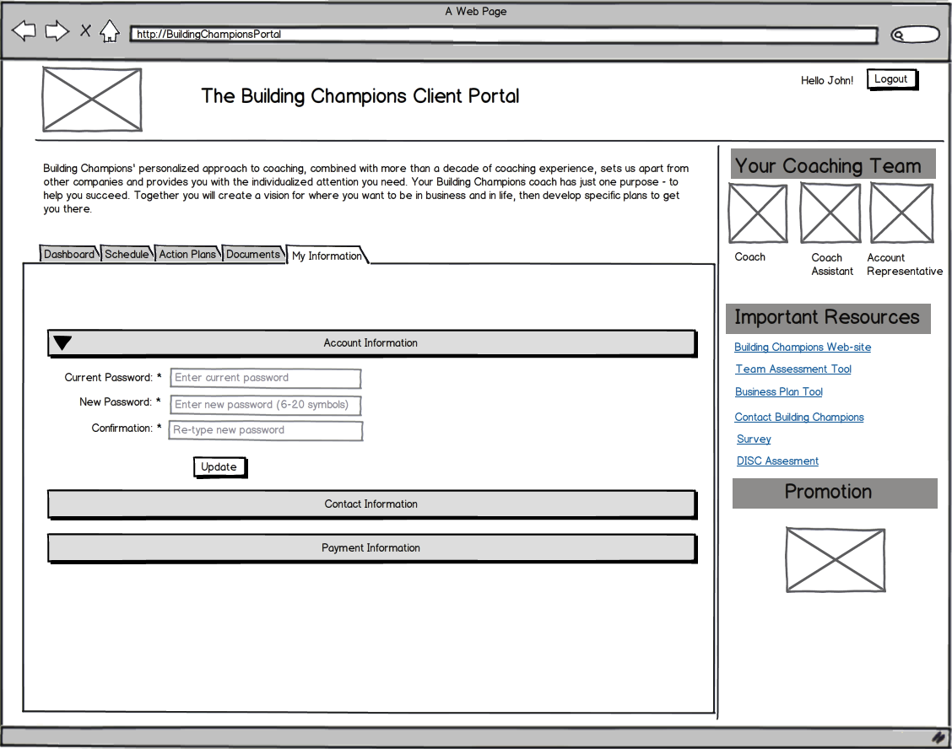

75. Client can update the password. Password has industry standard security requirements. The System validates entered passwords: min 8 characters (e.g. upper- and lowercase Latin letters, digits, special symbols).

If there are any errors the System shows warning.

**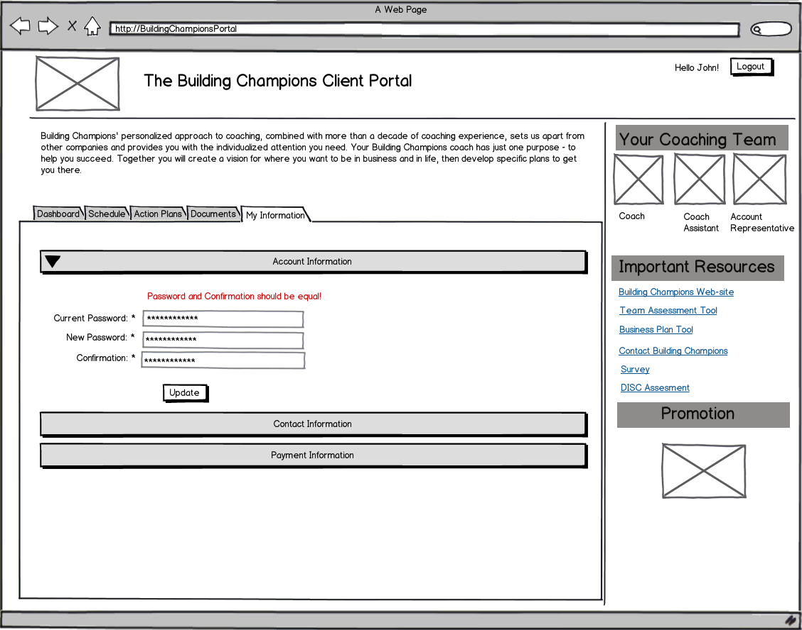**

76. Client clicks on the section **Contact Information.**

77. The Systems opens section **Contact Information.** Client can update general contact information that s/he entered while completing client information form. When the contact information is updated the System sends an email notification to the Coach Assistant of the old information and the new information.

78. Client clicks on the section **Payment Information.**

79. The Systems opens section **Payment Information.** Client can update payment information:

1. Payment options: **Pay In Full** (**Check** or **Credit Card**) or **Monthly payment plan** (**Automatic Check Deduction** or **Credit Card**). The filed **Credit card** has next options: MasterCard, Visa, Discover, American Express.
2. Card Number (the last 4 numbers).
3. Expiration Date.
4. Name on Card.
5. Billing Address.

When the payment information is updated the System sends an email notification to [accounting@buildingchampions.com](mailto:accounting@buildingchampions.com). Email template:

*Subject:* “Client Portal Notification”

*Body:* “Client <Name Surname> has just updated payment information on the Portal.

<Field Name>: from <Old Value> to <New Value>.”

## Work with Administrative Console

System administrator can update user information and questionnaires.

80. System Administrator view the list of all registered system users on **User Management** tab.

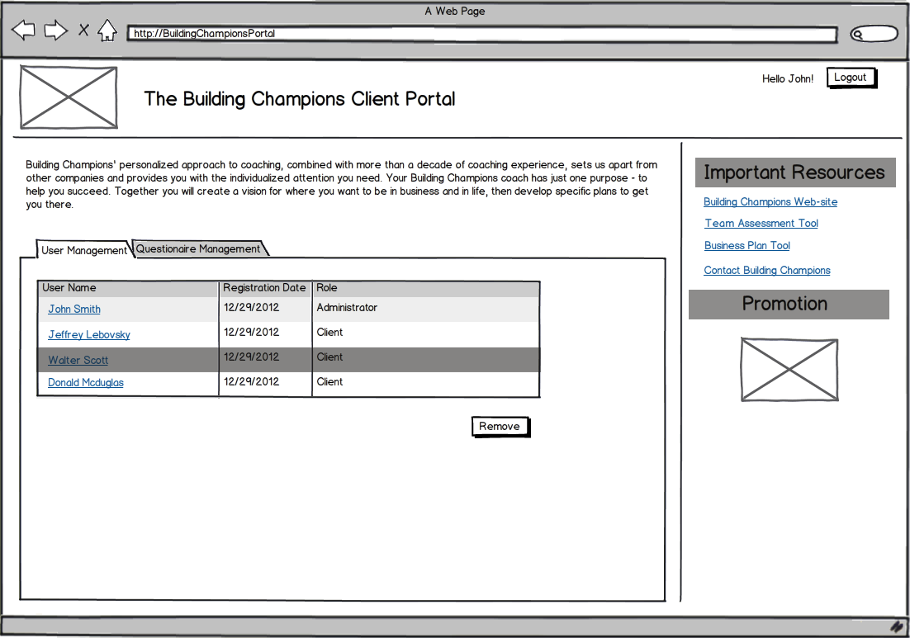

81. System administrator can remove user from the system by selecting line with username and clicking **Remove** button (**Remove** button is unable until user selected).

82. System Administrator can view user activity log by clicking username. The next user activity can be viewed:

* User log on/log out to the Portal;
* User marks Action Plans as complete;
* User updates any information (when and what);
* User reschedule a Session;
* User uploads a document.

**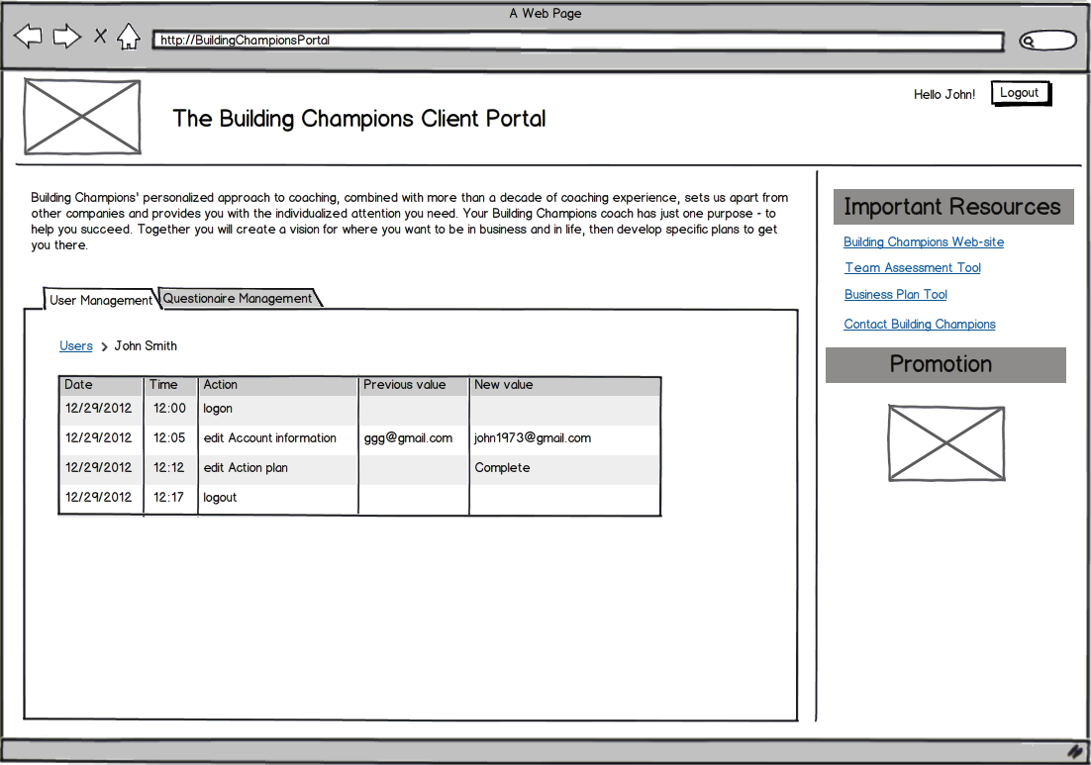**

Note: To return to the list of users, System Administrator clicks on link (breadcrumb) **Users**.

83. System Administrator view the list of Questionnaires on **Questionnaire** **Management** tab.

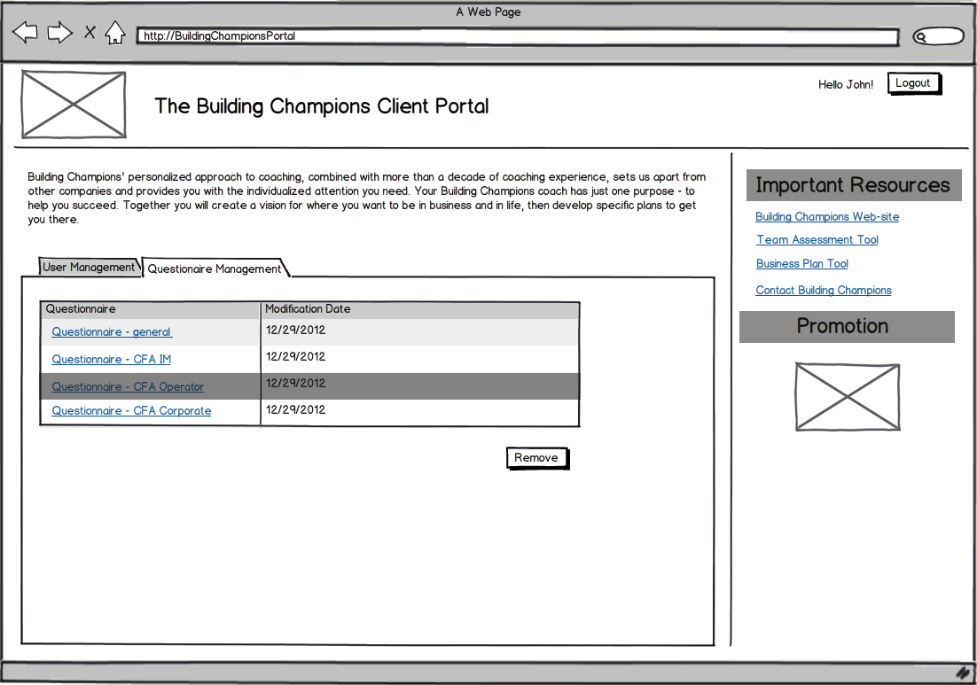

84. System administrator can remove questionnaire from the system by selecting line with questionnaire and clicking **Remove** button (**Remove** button is unable until user selected).

85. System Administrator can view the section of the Questionnaire and edit them (add or remove sections) by clicking on questionnaire name.

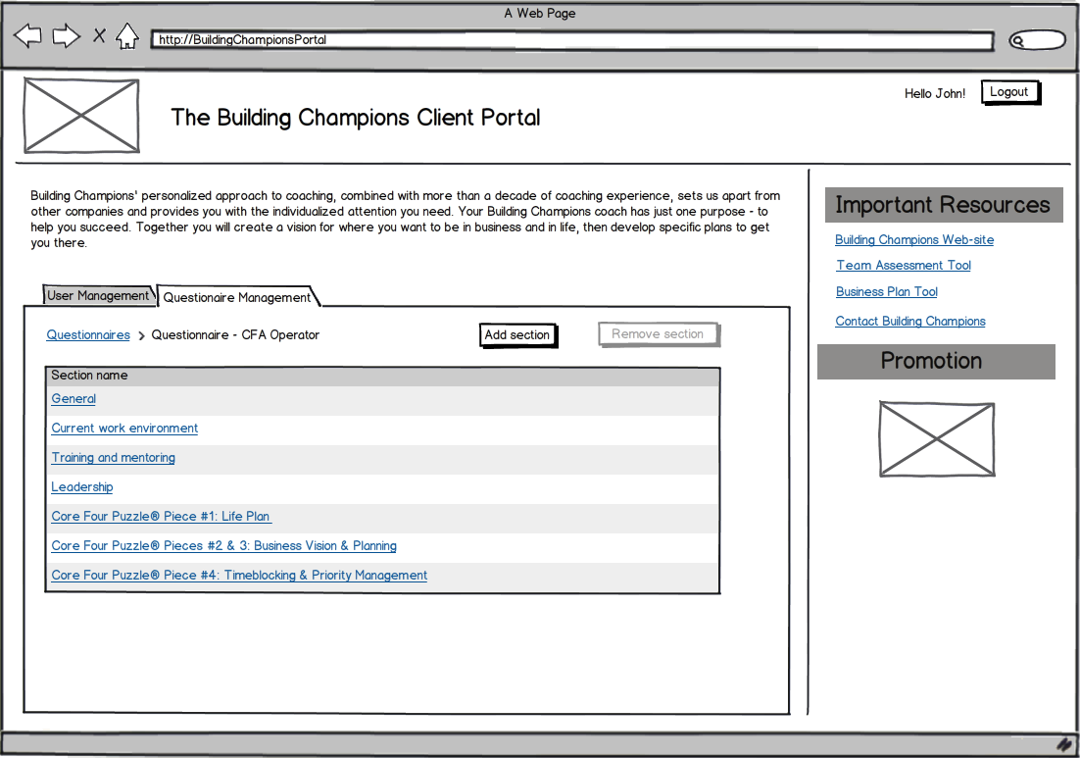

Note: To return to the list of questionnaires, System Administrator clicks on link (breadcrumb) **Questionnaires**.

86. System Administrator can add a new section to the questionnaire by clicking **Add section** button.

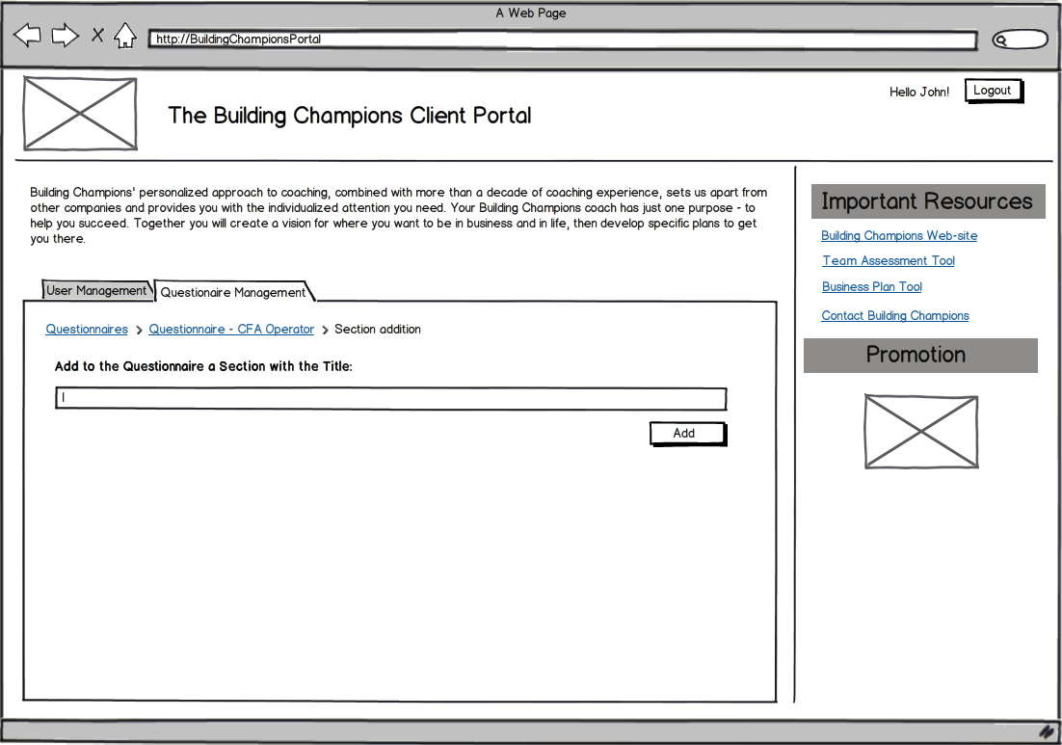

87. System administrator can remove section from the questionnaire by selecting line with section name and clicking **Remove section** button (**Remove section** button is unable until section selected).

88. System Administrator can view the list of questions of the questionnaire section and edit them (add or remove questions) by clicking on section name.

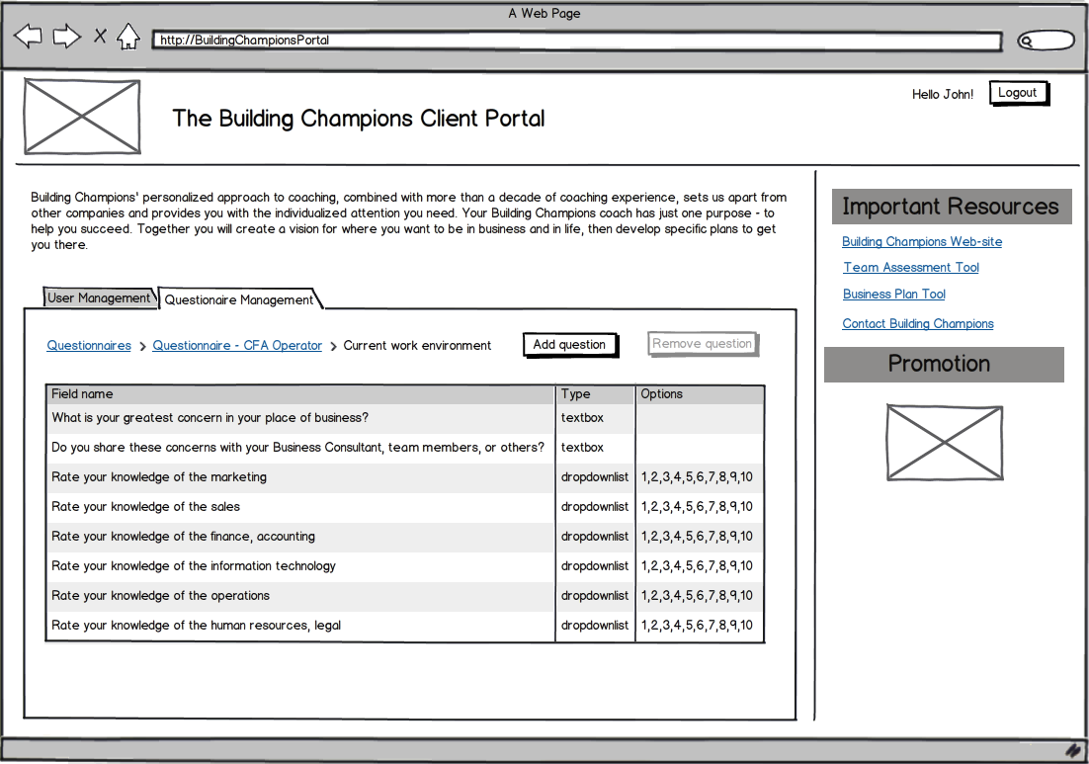

Note: To return to the list of sections, System Administrator clicks on link (breadcrumb) with thequestionnaire name.

89. System Administrator can add a new question to the section by clicking **Add question** button.

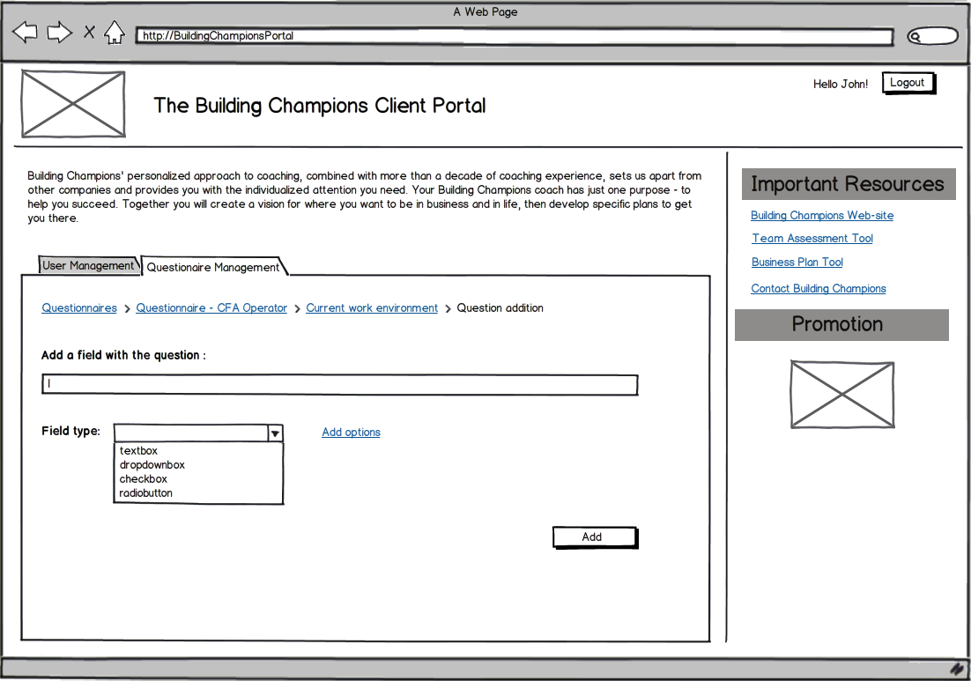

System Administrator selects one of the field types:

* TextBox – s/he just saves the field by clicking **Add** button.
* DropdownBox, CheckBox (max = 10 selection), RadioButton – s/he add a possible options by clicking a link Add options (in a modal window) and then click a button **Add**.

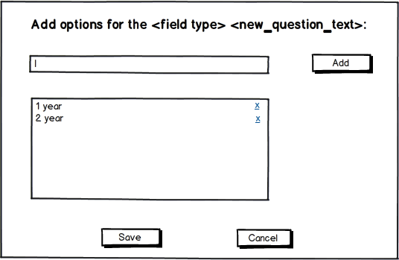

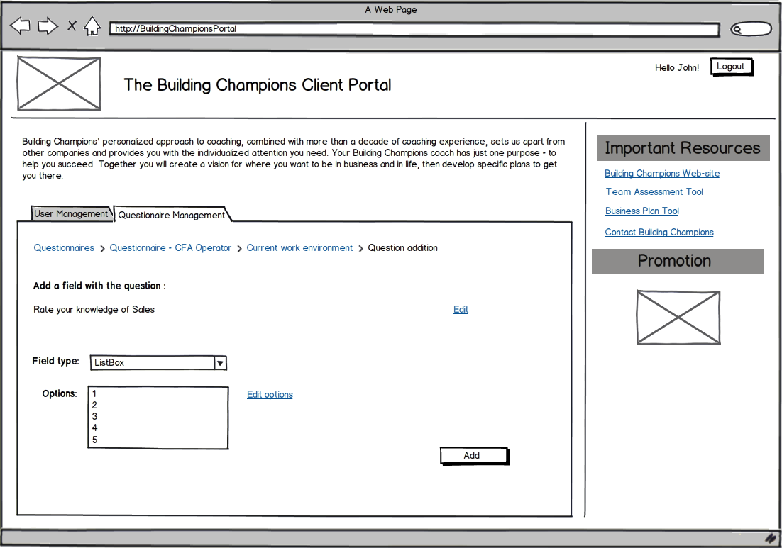

If System Administrator selects another option in the **Field type** after option adding, the System shows dialog with warning: “After selecting new Field type previous options will be removed. Continue?” and buttons: Yes, No.

Note: To return to the list of questions, System Administrator clicks on link (breadcrumb) with thesection name.

90. System administrator can remove question from the section by selecting line with question and clicking **Remove question** button (**Remove question** button is unable until question selected).

## Integration

System should be integrated with other applications and services SageCRM.

### SageCRM

System should be integrated with SageCRM via the Sage CRM .NET API. SageCRM developers guide can be found here: <https://community.sagecrm.com/user_community/m/default.aspx>.

### Box.com

Integration with Box.com cloud service should be done via Box API.

## Assumptions

* System should not handle Questionnaire answers, just store them as .pdf file.
* Cloud service Box.com should be used for storing documents.

Document History

|  |  |  |  |
| --- | --- | --- | --- |
| Version | Date | Owner | Description |
| 1.0 | 12/13/2012 | Yushkite Katerina | An initial version is created. Stage 1 description. |
| 1.1 | 01/08/2013 | Yushkite Katerina | Stage 2 description is added. |
| 1.2 | 02/12/2013 | Yushkite Katerina | Stage 1 description is changed. |
| 1.3 | 02/15/2013 | Yushkite Katerina | Pre-phase is updated. Pictures for Initial Onboarding (Client Information Form) and tab Schedule are updated. |
| 1.4 | 04/01/2013 | Kostya Pilkevich | Administrative Console, Integration, Assumptions section are added. |
| 1.5 | 04/05/2013 | Yushkite Katerina | Stage 1 description is changed (step Complete Your Questionnaire added, step Complete Your Pre-Coaching Survey is changed). Administrative Console description is changed. |
| 1.6 | 06/20/2013 | Yushkite Katerina | Section Review and Sign Your Contract are removed. Integration with SignNow service is removed. |
| 1.7 | 07/17/2013 | Yushkite Katerina | Files with Client Information Forms and Questionnaires are added. Description Client Information Form fields is added. Tabs My Information, Documents are updated. Mockups with option addition are added. |
| 1.8 | 07/23/2013 | Yushkite Katerina | Appendix v.1.0 is created. Fields for Client Information Forms and Questionnaires are put into Appendix. Email templates are added. |
| 1.9 | 08/16/2013 | Yushkite Katerina | Minor changes. Appendix v.1.3. |